Technical Report

Portfolio report

Fredrik Fordelsen

Word count

Summary: 250 | Main text:500

Table of Contents

1. Summary 3

2. Body 4

2.1. Introduction 4

2.2. Main section of report 4

2.3. Conclusion 13

3. References **Feil! Bokmerke er ikke definert.**

4. Acknowledgements **Feil! Bokmerke er ikke definert.**

5. Appendices **Feil! Bokmerke er ikke definert.**

# 1. Summary

This portfolio project consisted of planning, designing and coding a website that was made to showcase the work that I had done during my first year of Front-End Development at Noroff. I made four different pages for my website, to showcase some information about myself, the assignments that I’d done, my CV and a contact page.

I didn’t really find this too challenging, as I had the opportunity to learn from my past mistakes from other assignments.

# 2. Body

## 2.1. Introduction

This report is going to be documenting the process of making my own portfolio page. My first thoughts were that I wanted to make my website as professional and accessible as possible.

The project spanned over two weeks, and I spent the first part of the project timeline to design and plan how I would spend my time. I also tried my best to make the website as if I would have made it as an actual freelancer that wanted to showcase myself to potential clients.

## 2.2. Main section of report

As mentioned in the introduction, the first things that I did at the start of the project, I started making designs for my website:

On the following pages, I will be showing my different designs:

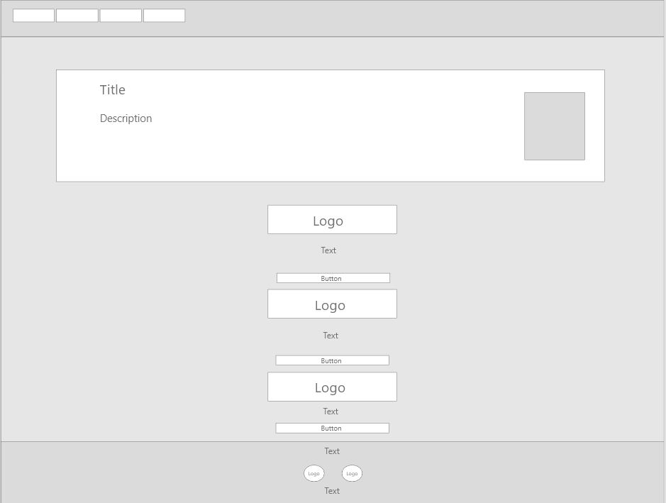

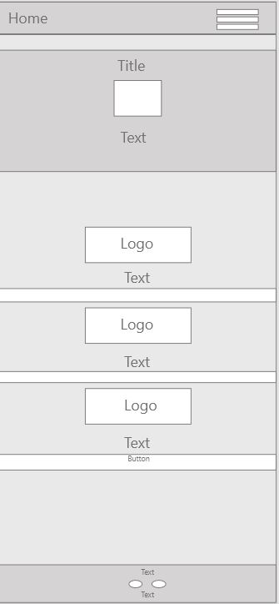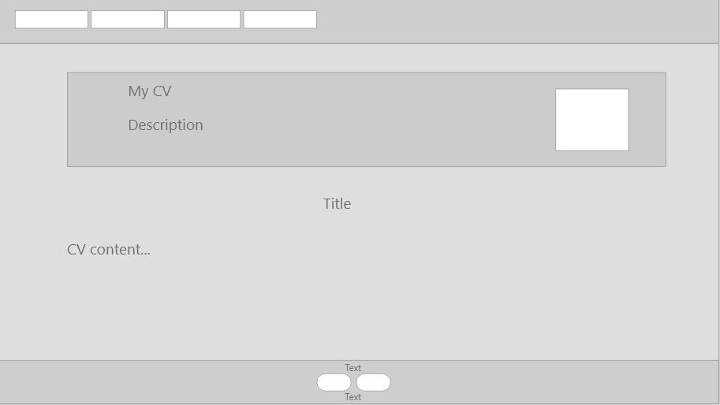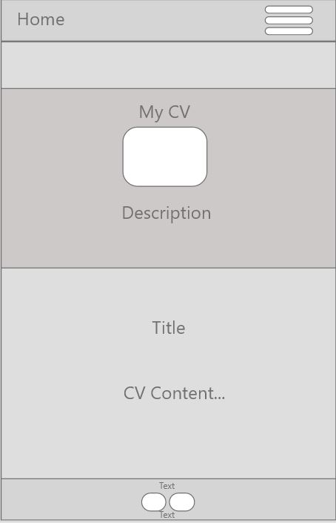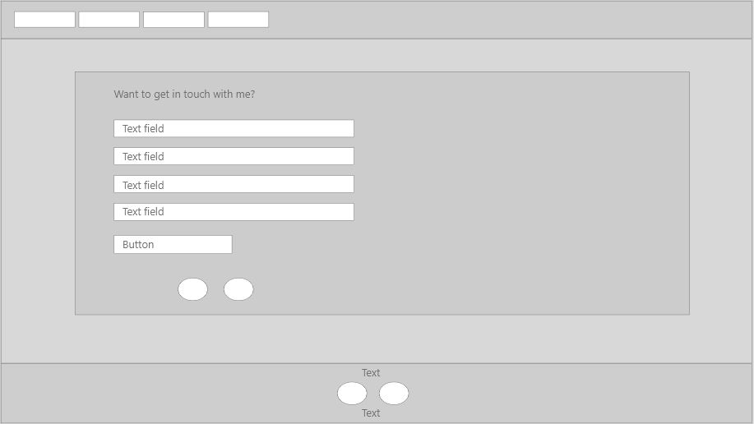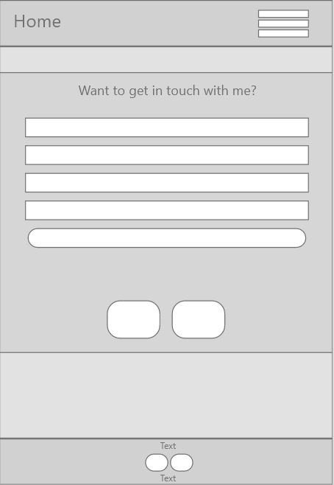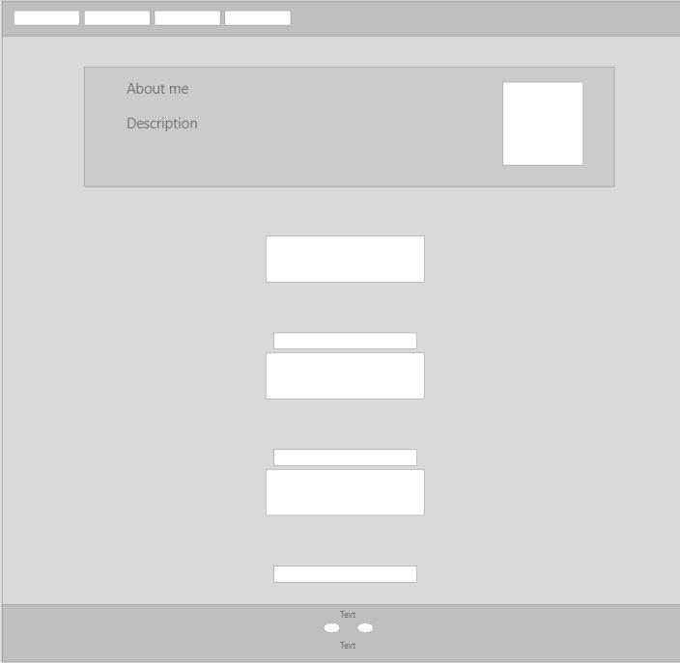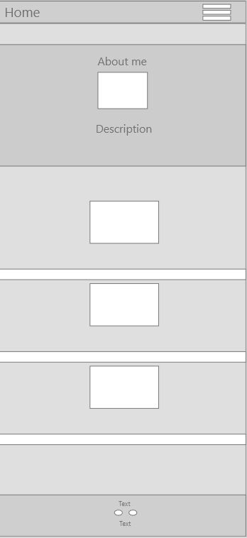

## 

As you can see, I have made some slight changes from my design to my actual website. For example I chose to remove logos and buttons from my homepage and keep them on the about page instead. I made this decision to give the user more incentive to visit the different pages.

All of my design choices were made based on this style tile that I made, and the font that I used was Roboto:

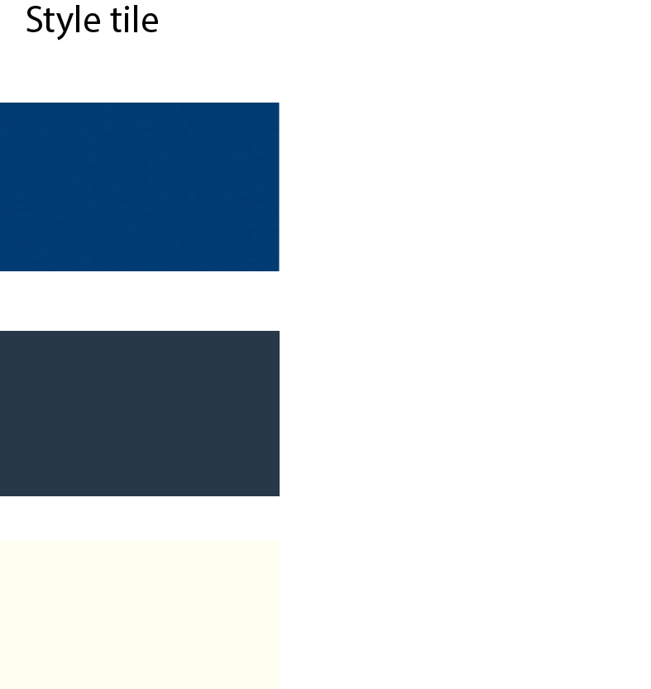

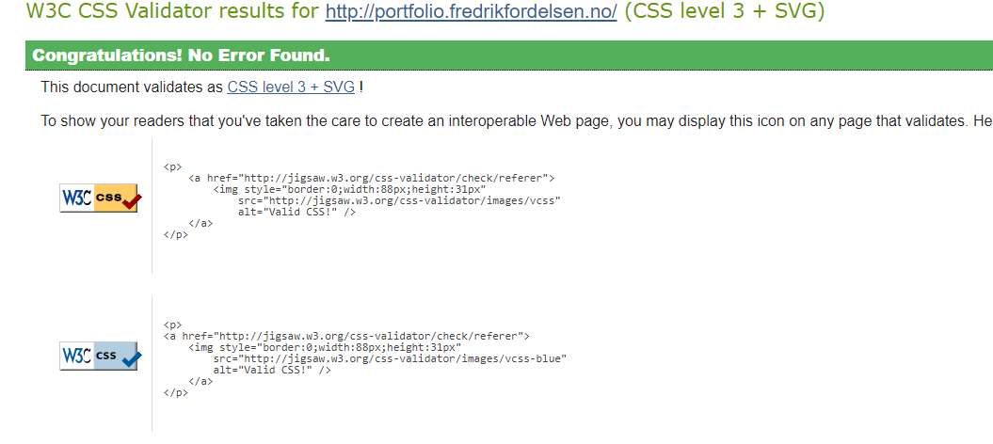

I also validated my CSS code, which ended up having zero errors.

Other than this I heavily focused on making sure that my website was responsive, so that people would be able to view it regardless of if they were using a desktop or mobile device.

Links to my work can be found at:

<http://portfolio.fredrikfordelsen.no/>

<https://github.com/btfredr/fredrik-fordelsen-portfolio>

I have included all my designs and project elements in my GitHub repository.

## 2.3. Conclusion

By doing this portfolio project, I learned what it takes to make yourself a presentable website, as well as which elements are important to presenting you and your work to potential clients in order to get hired.

Many of the things that I’ve done during the duration of this assignment will definately be taking into consideration in my future work. Something I also noticed was that I was able to correct previous errors that I’d made in my old assignment. These were things like errors in code and WCAG requirements. I feel like I have accomplished things that I made errors on in the past.